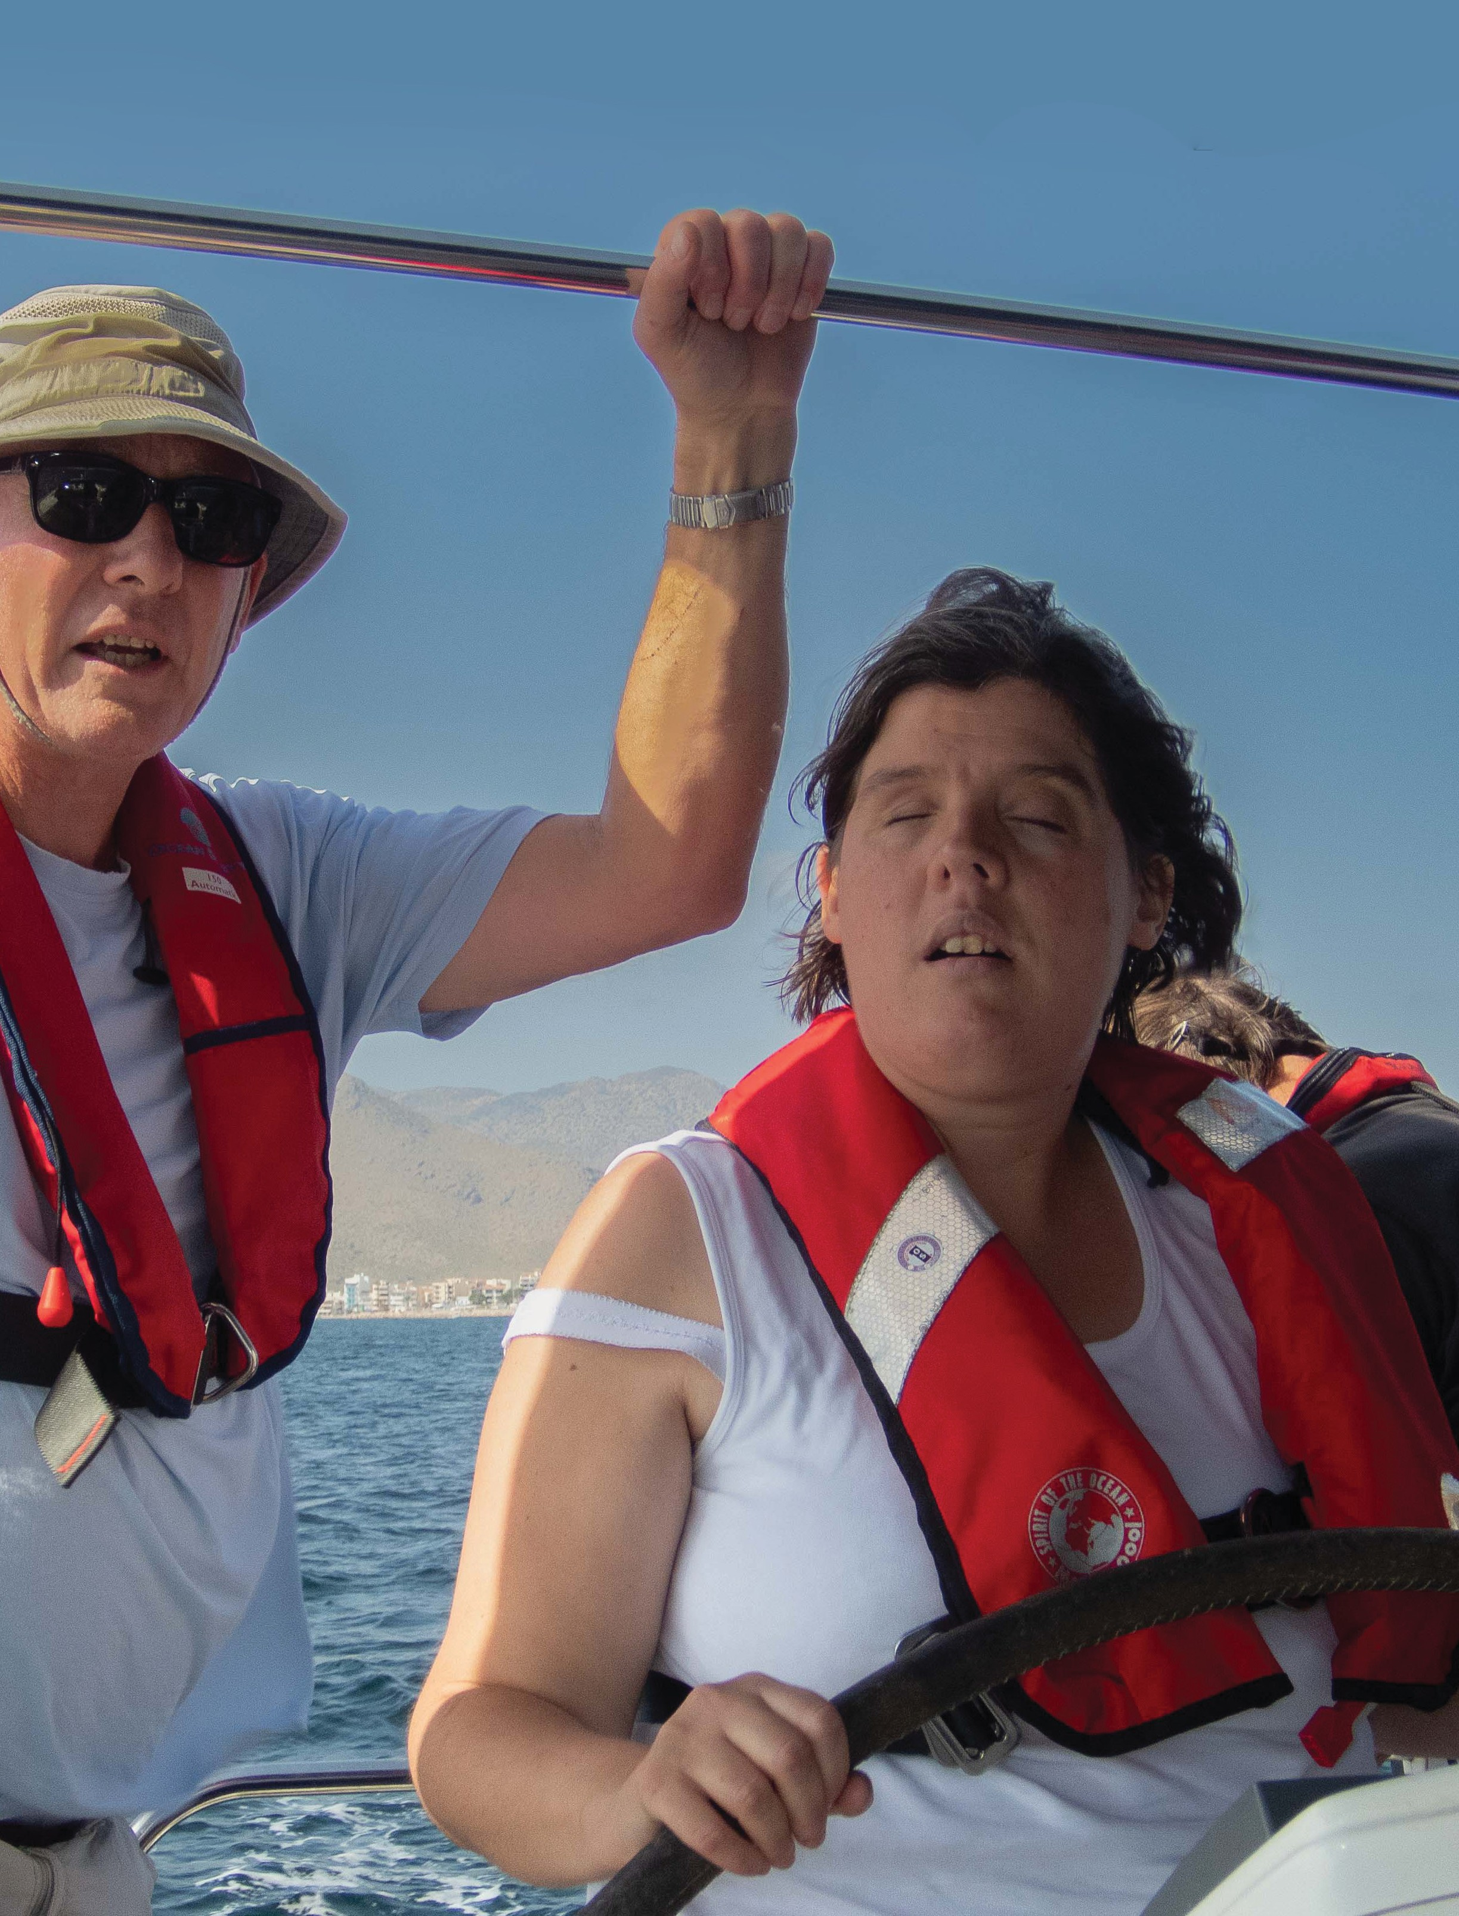Warwickshire
c
Spring 2020
Vision

• Sailing the Med
• Focus on Vision 2020
• Accessible Stratford

Supporting people living with sight loss in Warwickshire since 1911

Contents

Editorial ........................................4

News Round-Up ..........................5 Events Round-Up ........................8
Features ..................................... 10

Focus on Health ....................... 21

Spotlight on Equipment......... 24

Advice and Guidance .............. 26

Volunteer Focus ....................... 32

Quiz Page .................................. 34

Acknowledgements

Grateful thanks are expressed to Rosemary Went and Rosalie Visick and all contributors to the magazine. We also thank Kenilworth Talking News Association for producing the digital audio version of Warwickshire Vision.
In the Focus on Health section, we acknowledge the use of information from: Front Cover Image: courtesy Karina Gregory. Image (P7) Copyright Tommy
Trechard/Sightsavers. Image P 26 courtesy Mudstacle.com

Don’t Bin it – Recycle it

When you have finished with your copy of Warwickshire Vision, why not pass it on to someone else to read? You could drop it off at your local library, doctors surgery or opticians or you can pass it on to a friend or neighbour who may be interested.

Do your bit for the environment and spread the message of WVS.

3

Editorial
by Phil Arkell - CEO

Many of you will have heard about VISION 2020 UK but may not really know what benefits it has brought and how it has impacted on your life over the last 20 years. In this edition, we are going to explore the targets set by Vision 2020 UK and look at
how Warwickshire Vision Support has developed its services over the last two decades to meet these needs.

Established in 2002, VISION 2020
UK was set up as part of a global initiative by the World Health Organisation and the International Agency for the Prevention of Blindness to reduce preventable blindness. It is an umbrella organisation which facilitates greater collaboration and co-operation between organisations within the UK which focus on vision.

The Vision 2020 UK objectives are:
• To prevent avoidable blindness
• To improve the quality of services to vision impaired people
• To improve the training to professionals providing advice and services
• To improve communication between organisations within the VI sector

• To improve the availability of information to vision impaired people
• To ensure that the voices of the vision impaired are heard
• To raise public awareness of the issues and problems relating to sight loss

I think we would all agree that we have seen many improvements. However, years of austerity have also presented challenges to
the VI community. We now face a reduction in public transport provision (particularly in rural areas), cuts to local authority spending, longer hospital waiting lists and
the opportunities and challenges presented by the digital revolution
– all at a time when the numbers of people acquiring sight loss is increasing at an incredibly fast rate.

4

News Round-Up
Thank You and Farewell
By Phil Arkell

Judy Murdoch, our Vice President, is set to leave Warwickshire and retire from her activities supporting Warwickshire Vision Support.

Having joined us in 1986 Judy has undertaken many duties and held many positions over the last 34 years.

Judy was instrumental in setting up the Henley VIP Club (the precursor to the Henley Lunch Club) and also acted as a stop-gap leader of the Warwick Club for 6 months before
it eventually merged with the

Leamington Club.

Judy joined the Board of Trustees
in 2002 for 6 years, 3 years as Chair. Speaking of that time, Judy told us:

“In 2005, being chair was somewhat of a poisoned chalice with income and confidence at an all time low. We were buildings rich and cash poor! With the help of the then Manager, John Davis, I sold the building in Warwick and leased an industrial site in Whitnash so that the cash could be used to build up the financial stability of the charity. Somehow it worked!”

In 2008, Judy was made Vice President in recognition of her long standing contribution to people living with sight loss in Warwickshire.
She continues to support our
activities, volunteering for the Leamington Home Visitor Service and delivering fascinating talks on her globe-trotting activities to practically every club across the county.

In recognition of her contribution
to to her local community, Judy was recognised in the Mayor’s Annual Awards for Leamington Spa in 2017 and received our own volunteer award last year.

On behalf of the Trustees, staff, volunteers and service users of Warwickshire Vision Support, I would like to thank Judy for all that she does and wish her a very long, happy and well deserved retirement.

5

Making a Difference

Warwickshire Vision is proud to
announce that Sue & Jim from Nuneaton were part of the team that contributed to the ‘sight loss: what we needed to know’ booklet which
is now routinely given to all patients when you receive a CVI from your consultant ophthalmologist.

The booklet can be downloaded at warwickshire.vision/news/ sight-loss-what-you-need-know.

This important document won the Team of the Year award at the Vision Pioneer Awards 2016 held in London.

The information included is written for both people diagnosed with sight loss and their family and friends. It gives information on:

1. The emotional impact of sight loss
2. What sort of help is available
3. Explaining the certificate of vision impairment (CVI)
Legacy Gift Update
4. What it means for work, education
and training
5. The benefits to which you might be entitled
6. Our top 10 tips
7. Your rights under the Equality Act
8. Where you can go to get more help and support

We announced the notification of a substantial legacy gift in the last edition of our magazine.
The full size of the generous gift is still to be finalised with the donor’s estate. We hope to receive confirmation of the full amount by late spring or early summer. However, this is not stopping our planning process. The Board is actively developing a process and plan to ensure that we include service users, staff, volunteers and the trustees in this planning. We want to be sure that our charity derives the maximum benefit from this unexpected gift.

We expect to kick off the process in late Spring. As more information becomes available to us, we look forward to sharing the good news.

6

You Said... We Did...

It is now six months since we had our AGM and we thought it would be a good time to share with you, how
we have responded to some of your recommendations:

Suggestion: Change the layout of tables at Support Centres to encourage people to mix.
Action: We tried this at the Support Centres with mixed reception. Layouts have now been agreed at each venue

Suggestion: We should provide IT study notes after each session to aid learning
Action: This is available upon request

Suggestion: People also need help with ‘non’ smart phones
Action: We have sourced some of these phones and are looking at purchasing some demonstration models

Suggestion: There are training gaps for Volunteers
Action: We have developed our own internal training programme
to provide an Introduction to WVS; Living with Sight Loss; Sighted Guiding and Safeguarding courses.

Suggestion: Volunteer role descriptions should be accessible to all volunteers so they can undertake more activities if they choose. Action: Role descriptions are available on our website and at our new training sessions

Suggestion: Volunteers would like to receive more information about activities local to them so they can contribute
Action: We have improved our communication with volunteers to keep everyone fully informed

Suggestion: Club/Social activities for younger people
Action: We will undertake research to see what is currently available and what people would like. This will form part of our strategy going forward

We would like to thank everyone who contributed to make the AGM such as success.

7

Events Round-Up
Warwickshire Vision takes on the Wolf Run

A team from Warwickshire Vision Support will be taking on the Leamington Wolf Run on weekend of
8
5th and 6thSeptember to raise money for the charity and raise awareness of sight loss in Warwickshire.

The decision to submit a team came from Del Hobden our volunteer
co-ordinator who completed the run last year.

The team comprising Del, Louise Jelley, Andrew Baker, Vicky Lewis, Ebony Rushforth and Phil Arkell will take on the famous 10km run over (and under) obstacles and of course through rivers of mud.

The team plans to stay together and support each other for the duration

8
of the run. “Our objective is to firstly survive the Wolf Run, secondly for
all of us to complete it and thirdly to raise some funds for WVS” Del told us.

If you wish to sponsor the Wolf Run team, then please either:

• Complete a sponsor form at your local Support Centre or Club
• Send a cheque to the office stating
‘Wolf Run’ on the back
• Make a donation on our localgiving.com page

Pop up Events

Thanks to the support of the Lottery and Warwickshire County Council,
we have developed a pop-up service for people who are geographically isolated and have difficulty accessing our mainstream services. To date,
we have hosted 24 Pop-Up Support Centres from Polesworth in the north to Shipston in the south.

Usually based in local libraries or resource hubs, they provide access to information, advice and guidance
as well as a wide range of portable demonstration equipment.

The take up has been considerable. Of the 24 sessions held so far, we have talked with 114 people and generated 111 referrals. These referrals can be for Rehabilitation Support, to join a club, receive IT training, apply for a blue badge
or simply to learn more about a particular sight condition and the services available locally.

Our next pop-ups will be:

9

Town | Venue | Date | Time
 |  |  | 10am - 12 noon
 |  |  | 2 pm - 4 pm
 |  |  | 10am - 12 noon
 |  |  | 2 pm - 4 pm
 |  |  | 10am - 12 noon
 |  |  | 2 pm - 4 pm
 |  |  | 10am - 12 noon
 |  |  | 2 pm - 4 pm

Staff Changes

Since our last edition we have welcomed Barbara Hines to the team. Barbara is an Assistant Vision Support Officer who will be based at the Leamington and Stratford Support Centres.

9

The Technology Revolution
by Karina Gregory

Twenty years ago technology for people living with sight loss was very much behind the times and
almost completely separate from the mainstream devices. For example,
if you needed a mobile phone to read out screen text you had to send your mobile away to have it installed, sometimes at a cost of £150!

I had my first desktop magnifier in the early to mid 90s and it came in separate components; a reading table that had a camera over it, a lamp to the left to illuminate the text so that the camera could create a reasonably clear image and a screen not dissimilar to an old fashioned
portable television screen. In those days, the clarity of picture was variable and I had to adjust the screen each time it drifted off channel.

What a revelation it was when an all- in-one desktop CCTV came onto the scene in the late 1990s. Admittedly, you needed a spare room to house it and a fork lift truck to move it but it was a major step forward.

Fast forward to today, and we have light weight, semi portable CCTVs that provide high definition colour imagery and the ability to read the text.

10

10

Similarly, for those of us that read Braille, refreshable Braille displays were enormous - with a big area to store the battery they took up most of the room on your desk. Today, they can fit into your pocket.

Over the last decade, technology has progressed so much that mainstream companies now fuly embrace accesibility and incorporate it into all of their products.

I remember the first time I turned my Samsung phone on, it told me that if I needed to use speech to help me set it up, I should draw a triangle on the screen - low and behold it worked!

Apple has led the way with text- to-speech software but it is now commonplace on almost every mobile phone. To be able to point the camera at a document and have it read the content is amazingly empowering. Meanwhile, the phone’s camera also acts as a magnifier meaning that I don’t have to carry lots of pieces of equipment with me when I go out.

Nowadays mobile phones and tablets can substitute so much of the specialist equipment we once
needed - and it doesn’t have to cost a fortune. A second hand smart phone can costs as little as £30 - although most of us have children and grand children who have drawers full of redundant devices. In most cases these can provide exactly what you
need at practically no cost.

This digital revolution means that we can access the information in which ever format is best; speech, Braille or large print using a variety of contrast settings. This has given back to me my privacy and my indepedence. I
no longer have to rely on others to read my personal correspondence.

Of course the digital divide is a gulf that for many is too intimidating
to cross. This can lead to greater marginalisation and frustration. That is where WVS are here to help.

I have recently joined the IT training team as a volunteer. I want to share my knowledge and
experience because I know just how empowering technology can be.

I hope that I have inspired you to take up the digital challenge. Warwickshire Vision Support is here to help. There is an exciting world out there full of entertainment, convenience, connections and savings.

If you want to find out more, or perhaps see a demonstration, then why not visit one the Warwickshire Vision Support Centres or call Ruth Okey on 01926 411331 to make an appointment.

11

11

Digital Clouds don’t always have a silver lining
by Jemma Davoudian

You will often hear us eulogising about the benefits of digital technology and its potential to empower people living with sight loss.

Indeed, technology has had a remarkable impact on the way we operate as a society. It affects how we manage our money, organise
our appointments, do our shopping, communicate with friends and family and much, much more.

However, the technological revolution is not accessible to all.

People with sight take the ease and convenience of their online activity for granted. High streets are being devastated by online retailers who can almost always beat the traditional retailer in
terms of range, stock and of course price. To compete, the larger stores are moving out of town - often
to locations that are increasingly inaccessible to visually impaired people dependent upon public transport.

This is further exacerbated by the impact on local convenience stores that cannot compete with the likes of Aldi or the ‘Big Four’ supermarkets.

Across Warwickshire, our villages are losing the community facilities such as corner shops and pubs at an alarming rate.

The impact of the digital revolution does not stop there. As more people use internet banking over visiting their branch, sending emails rather than posting letters, the demand

12

for Post Office services has dropped resulting in their demise.

It is not uncommon to find villages with almost no local facilities for the residents. This may not be a problem for those with cars - but is a major challenge for the rest of us.

For the working age population, the digital revolution becomes especially challenging when navigating the employment market.

Gone are the days when you could hand in a paper CV. Job adverts are now almost exclusively posted online, and despite government policies being in place to tackle employment discrimination, many
industries are failing to fairly recruit people with a disability. In a recent survey, 72% of disabled workers
at a software company did not believe their employer had the right adaptations in place to support them.

For those who cannot find employment, the challenges continue. Many benefits, pensions and concessions can only be applied for online and a lack of access could seriously affect your income.

Of course, there are organisations like the DWP and Citizens Advice who can help with applications
but availability is often limited and appointments can be postponed
if you are unable to locate all the relevant documentation. This can
be a major problem faced by those living with sight loss.

Increasingly we see front line services replaced by internet portals and telephone systems using artificial intelligence. Operators are often replaced to reduce the costs of these services. This is all done in the name of efficiency. However, this it is yet another barrier to VIPs who want to ask a person for help and advice.

Overall, the tech revolution has been a huge stride forward. However,
it’s failure to carry along the elderly and less technologically minded has created a two tier sytem that has major consequences for those left out in the cold.

The lack of inclusivity of the internet age seems to hang over society like a dark cloud. However, we cannot turn back time, the future is digital and it
is here to stay.

If you want some help to overcome the digital divide, then why not
pop into one of our support centres and talk with Ruth about IT training sessions, or call 01926 411331.

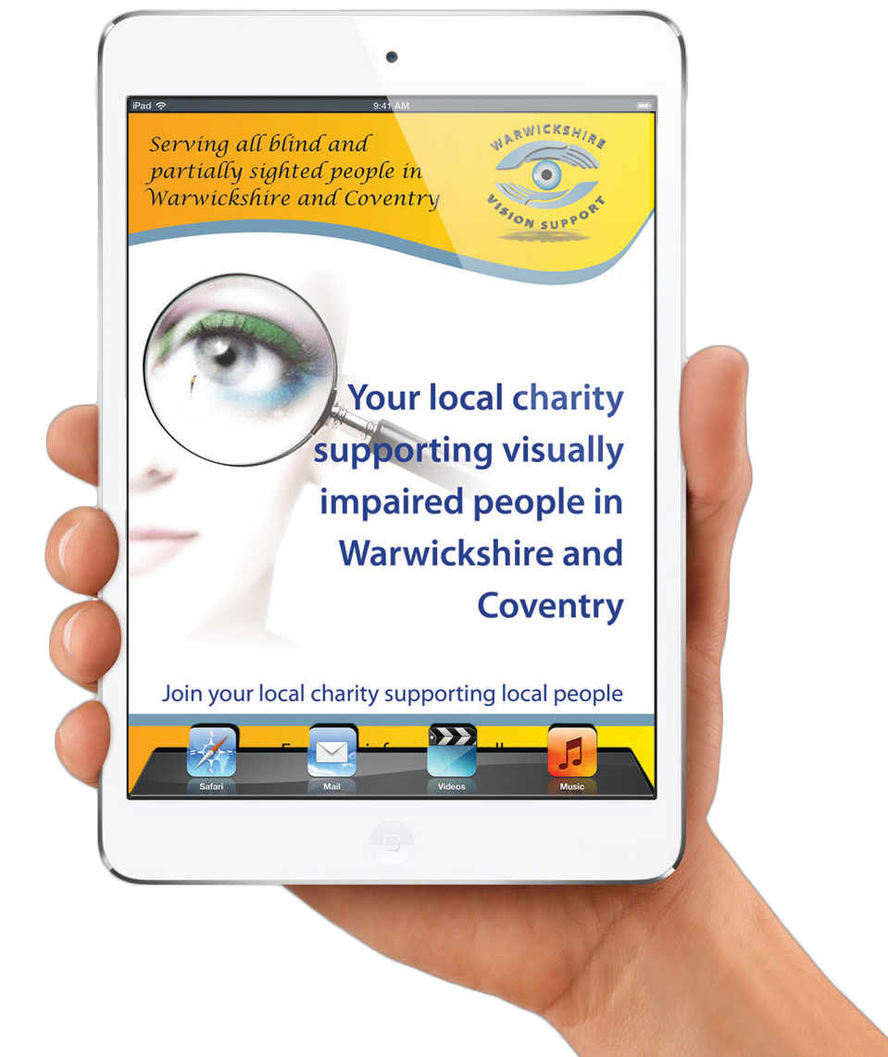

13

Fighting for our Rights
Louise Jelley interviews Elizabeth Dixon

14
Elizabeth Dixon is a Disability Advisor in Stratford-upon-Avon.

Elizabeth joined West Midlands Police in 1967 and enjoyed a varied career which included becoming the first female police dog handler in the country. After her Police
Dog, Czar, retired she spent a few years on patrol in the Digbeth area of Birmingham. On 1st March 1986
Elizabeth’s life was changed forever when she was involved in a serious road traffic collision on the Aston Expressway whilst out on patrol. The accident left Elizabeth in a wheelchair.

Today, Elizabeth is a force to be reckoned with when it comes to Disability Rights. Elizabeth was interviewed by Louise Jelley at our Stratford Vision Support Centre.

Elizabeth, your accident left you with life changing injuries, how did
you cope in the years that followed?

It took me about 3 years of recovery to ‘get my voice back’ and feel confident again. I was still in my 30’s and I still wanted to dress trendy - which was not easy when confined to a manual wheelchair. I refused
to allow the accident to define me and clung onto my own personal identity for as long as I could. The West Midlands Police and Police Care

14

helped me enormously following the accident and have done ever since.

Elizabeth, what brought you to
Stratford-upon-Avon?

In the aftermath of the accident I needed care and support but wanted to live independently in a village. I was able to drive for a number of years and would travel all over the country on holiday. I realised though, that I needed to live in a place where
I was not reliant on a vehicle and also somewhere that was relatively flat which would suit a wheelchair user.
I moved to Stratford about 20 years ago.

Elizabeth, how did you find Stratford-upon-Avon 20 years ago when it came to accessibility and inclusion?

I can remember not long after I had moved to Stratford, I went to the bank to withdraw some money. All of the banks were inaccessible to me
- I could not get my wheelchair inside the doors. Someone had to both accompany me to the bank and make the transaction on my behalf or a member of staff would come outside, collect my card and pin number and then make the transaction without me. I raised this with the bank and

Elizabeth, tell me about some of your achievements?

I have worked closely with the Leisure Centre which is now leading the way with regards inclusion. It has the only changing room and
toilet with a hoist in Stratford. It also has hearing loops, makes literature available in Braille format and even has an area designated for the exercise of assistance dogs. I am currently very active supporting
the council in making Stratford a
Dementia Friendly Town.

also the council - that is when I started to challenge all sorts of issues on behalf of disabled people.

Whilst it is very different today, change did not happen overnight and the banks were just the tip of the iceberg when it came to accessibility on the high street. Revolving doors were a particular problem, they were either too small to fit a wheelchair or too quick to negotiate.

Over the years I have gradually involved myself with many organisations in Stratford and have become a Disability Advisor for Citizens Advice, Royal Shakespeare Theatre, Welcome Here, Clinical Commissioning Groups, SWIFT, GP Patient Group, Police Hate Crime Panel, Shop Mobility and of course Warwickshire Vision Support.
Elizabeth, what else needs to be done?

I am not sure who will continue my work in the future, but what I would like to see is a society whereby
there is no need for an Ambassador because it fully embraces inclusivity without the need for activism. I believe the only way that will happen is if the regulations around creating accessible spaces are made statutory.

Currently the changes advised to companies is only covered by Civil Law which means if a company does not make appropriate changes the onus is on the disabled person to
take them to court. If the regulations became statutory there would
be more compliance, thus more inclusion.

15
15

The Right Help at the
Right Time By Del Hobden

Being diagnosed with sight loss can be devastating, leading to social withdrawal, isolation and depression. Newly diagnosed people often feel frightened and vulnerable and do
not know where they can turn for support.

Our advice desks offer critical and timely support and information to the patient, family and carers about the nature and practical impact of their eye condition; what to expect in the future and what services are available to help. This early support increases the likelihood of a person
acquiring sight loss to lead a full and independent life

We work closely with staff in the eye clinics to help bridge the gap between healthcare and community services. With the strong link between our hospital advice desks, rehabilitation service and our charitable services we are able to give you access to a wide range of services:

• To learn about your eye condition so you can better plan and manage your sight loss
• Through early access to rehabilitation, be less prone to falls and accidents at home.
• To have better access to local
services that support you
• To have the chance to share experiences with mentors and peers and hopefully replace anxiety and uncertainty with knowledge and confidence
• To build confidence so you feel able to participate more fully in your local community, thereby improving both your physical and mental well-being.
• To reduce social isolation by helping you to create a social network that is capable of supporting you at difficult times.

We know that the right practical help and social support at the right time can transform a person’s life and to that end, Warwickshire Vision
Support has worked hard to establish a presence at each eye clinic across the county.

In early 2010, we established our first advice desk at the Machen
Eye Clinic at Warwick Hospital. The impact of the advice desk was soon appreciated by the eye clinic team and by 2013, we had secured funding to expand the service into Stratford Hospital.

However, the major step-change came in 2016 when we secured
3-year Lottery Funding for our My

16

Del and Maria at our advice desk at Warwick Hospital

Sight Project. This service, based initially at George Eliot Hospital in Nuneaton and more latterly at Camp Hill Medical Centre combined advice desk information and guidance
with social and emotional support delivered at our vision support centre.

It was on the back of this project that we were able to secure grants from the Dunhill Medical Trust, the Sobel Foundation, Garfield Weston and others to establish a more permanent presence across the county.

At this point, we started our weekly advice desk in Rugby to complement the work of the RNIB ECLO (eye clinic liaison officer) Sue Gruecock.
The service Warwickshire Vision Support provides at the hospitals has now evolved and become more formalised. We want to ensure that
you get the best service available and are pleased to say that we now have two team members, Vicky Lewis and Del Hobden, who are fully qualified Eye Clinic Liaison Officers (ECLOs).

Unfortunately, funding does not permit us to be at the clinics full time. But if you need information, advice and guidance and we are not there, then please either talk to the nursing staff who can pass on your details or call us on 01926 411331

17

Who Says Blind People Can’t Drive?
by Karina Gregory

In early 2019, I felt I needed a challenge and decided to pursue a personal dream of sailing - an
unusual goal given that Coventry is so landlocked.

Having consulted Google, I learned about the Jubilee Sailing Trust (JST ) who provide opportunities to sail on tall ships. I had a good look through their voyages and initially chose a short one from Portsmouth to Poole which lasted for 3 days. When you arrive on board you are assigned a buddy whom is there to offer any support or assistance you may need e.g. finding your way around the

18

ship. It was great because I had the opportunity to do everything that everyone else was doing - although I did get out of mess duty on my first voyage but I wasn’t going to complain too loudly about that!

Whilst on watch in the afternoon, it dawned on me just how relaxed I felt
- I had left my worries on-shore and
it was just me and the sea. I followed this trip with a longer London to Edinburgh voyage.

At about the same time, I heard about VISA GB (the Visually Impaired Sailing Association). I was invited
to join them on a short sail from

Lymington to Yarmouth on the Isle of
Wight.

VISA GB do not have their own boats, so I was told simply to make my way to Brockenhurst train station with
my sleeping bag. I was duly met at the station and my adventure began. What a great experience, meeting
lots of VIP sailors, sharing experiences and generally having a wonderful time.

This all prepared me for the big trip. On 12th October 2019, seven visually impaired crew members, a sighted Skipper and a sighted mate set out to Majorca to begin our VISA GB sailing holiday.

The VIP crew departed from different airports with the expectation that we would meet up at the airport. The Skipper and his mate would arrive later. Despite language problems
we were able to find each other and our luggage - thanks largely to our mobile phones.

Being a guide dog user it always comes as a bit of a shock to the system to have to revert back to using a cane. I had prepared myself as I knew my mobility skills would need to be in tip-top shape for negotiating narrow pontoons and their presenting obstacles (namely ropes, wires and lights).

After being shown around the boat by a rep from the boat hire company we made ourselves at home and

unpacked our things. Once the Skipper and Mate had arrived, a shopping party was assembled for the first shopping mission of the week. Meanwhile, the rest of us stayed on board getting to know each other and waiting for the shopping party to return.

One good thing about sailing is that there is a place for everything - and due to the limited space available there are few opportunities for people not to put things back where they had come from. This really
makes life easier for VIPs who spend a lifetime tripping over other people’s paraphernalia.

The following day after a very leisurely breakfast and the safety briefing which included being shown how to put on our life jackets, we set off for our first day of sailing.

We spent the next seven days exploring the Majorca coastline. We all had numerous opportunities to try out the tasks onboard, including dropping and lifting the anchor, helming (steering), managing the

19

Karina with her crew

sails, mooring the boat, casting off, and even refuelling at the end of the week!

It was a great opportunity to develop new friendships and learn new skills with people who
understood the real meaning of the word “empowerment”. The week culminated in a get together with another crew who were following in our footsteps.

I hope that my story inspires you
to explore the world and fulfil your dreams. We should not be defined by our sight loss, we may have to adapt our approach and it may take a little bit longer what does that matter? It
is that sense of achievement that is the most special and fantastic feeling in the world.
Travel Tips

1. Plan ahead. Break things down into simple steps that are easier to manage

2. Exercise patience - getting flustered only makes things worse

3. If you can use a smart phone, then Google translate can help with communication whilst navigation can help with meeting places

4. Take a photo of your luggage.
You can then ask someone to help you collect it off the conveyor belt

5. Remember to enjoy yourself - adventures can be great but try to build in some ‘me’ time

20

20

Focus on Healthby Jemma Davoudian
The Sight Test Revolution on the High Street

The last few decades have seen rapid changes in the way UK patients access eye tests. Just 20-30 years
ago, the typical visit to a high street optician would include a basic test and, if you were experiencing specific issues with your vision, the optician may have used an ophthalmoscope
to examine the back of your eye. In essence, you would not visit an optician unless you were already experiencing problems with your sight.

Fortunately, high street sight tests have now been completely revolutionised through technological advances. During a standard visit today, you will first complete pre- testing with an optical assistant.
This may include a tonometer test, where gentle puffs of air are used to measure the internal pressure of your eyes (vital in the early detection of glaucoma). Multifunctional machines now conduct multiple tests – such
as autorefraction (for long/short- sightedness) whilst digital retinal photography takes an image of the back of your eye.

Your optometrist uses the results gathered during pre-testing, plus any symptoms you declare, to assess your overall eye health.
Optical Coherence Tomography (OCT ) is a hospital-grade eye scan which is now being introduced to consumers by high street opticians, at a cost. OCT uses light waves to create a 3D
image of your eye, allowing distinct layers of the retina to be viewed separately, thus allowing opticians to detect signs of eye health
deterioration up to four years earlier than traditional methods.

Remember, even though you may be losing your vision, always visit your optician to maximise your usable sight.

Opticians can also detect other medical conditions:
• Diabetes: early signs of haemorrhaging
• High Blood Pressure : damaged blood vessels
• Cancer: abnormal eye structure
• Tumors: abnormal shape of pupils
• Arthritis: Inflamation of sclera
(white of the eye)
• Dementia: thinner retinas or
deterioration in the retinal cells
• Thyroid disease: bulging eyes
and much more...

Vision 2020 - A Global Perspective

Impaired vision can have an impact on all facets of life – from employment, to quality of life and beyond. Globally, at least 2 billion people have a vision impairment, of whom at least 1 billion have a
22
preventable condition, or one which has not yet been addressed.

Accurate estimates are near impossible to obtain because population-based surveys will not typically report on those who wear glasses or contact lenses.

In the World Health Organisation’s (WHO) 2019 World Report on Vision, it was estimated that 196 million people across the world suffer with age-related macular degeneration,
146 million have diabetic retinopathy, 2.6 billion have myopia and 76 million have glaucoma. Moreover, it is thought that at least
65.2 million people worldwide have unaddressed/untreated cataracts. This is a sobering realisation, as millions of people are living with a vision impairment that could have been prevented.
Successful solutions
One of the clearest successes of
Vision 2020’s investment in research
is the number of effective prevention methods now available in the sight loss sector.

Prevention can be successful by targeting eye conditions which are

22
secondary to other health issues, such as Vitamin A deficiency, measles or rubella. For instance,
through vitamin A supplements and immunisation, the risk of corneal opacities can be significantly reduced.

Equally, changes to legislation, like the compulsory use of a seat belt whilst driving, has also resulted in a large reduction in ocular injuries.

Treatments aim to cure eye conditions, or at least address their symptoms and progression.
Cataracts, for example, are a leading cause of vision impairment which is treated through surgical intervention. Cataract surgery is cost-effective,
can be performed by mobile clinics in developing countries and has a major impact on the quality of life of patients and the local economy.

Eye care now reaches some of the most remote communities

Sightsavers is one of the many international organisations fighting sight loss

Similarly, the development of anti- VEGF injections for the treatment of age-related macular degeneration has transformed the prognosis
of these conditions. Since their inception, high-income countries have seen a reduction in the incidence of blindness caused by AMD. Whilst promising, this does not mean that Vision 2020 has finished
its job – the availability of treatments like anti-VEGF therapy is scarce
in many low- and middle-income countries due to high associated costs. Vision 2020 is a global initiative, and therefore changes and improvements need to be seen for the entire population, not just specific sub-groups.

Looking ahead

Technological advances funded and endorsed by Vision 2020 have also had a positive impact within the field of preventative eye care. Artificial intelligence can now detect a wide range of eye conditions, including diabetic retinopathy and trials of
mobile phone-based software that can conduct vision assessments are showing promise. These measures could revolutionise the diagnosis
of eye conditions, and enable interventions to begin at a much earlier stage.

The portability of these diagnosis tools also enables their use in more isolated or rural regions, and could help to alleviate the shortage of eye care professionals.

As we plan ahead, the global population of people aged 60 years and above is estimated to increase by
54% from 2017 – 2050. Add to this a steady increase in life expectancy and population growth, and it becomes clear that the work of Vision 2020
is far from over. Progress has been made for all major objectives and core strategies of this initiative, but
now we must build upon the findings and successes – 2020 itself is just the beginning.

23

23

Spotlight on Equipment
Jane Thorn looks at talking glucose monitors

You might be surprised to learn that glucose testing is nearly 100 years old! Back then, glucose monitoring required a sample of urine and a laboratory at the very least.

Fast forward 60 years or so and blood glucose monitoring could finally be undertaken in your own home. But this was a complicated affair with multiple steps and often inaccurate results. Continuous Glucose Monitoring (CGM) was a great step forward but it still required some useful vision to check the reading.

Living with sight loss can be challenging and exasperating. Living with sight loss and diabetes that needs constant monitoring, just adds another complication.

Talking glucose monitors have been around since the 1990s. There are now many different models available on the market to buy.

Speaking to your diabetic nurse or
GP should always be the first point of call for help, advice and assistance. Similarly, if you are struggling with monitoring your levels because of vision loss then talk to them about a talking glucose monitor.

You might find that your surgery will prescribe you a free talking glucose monitor. However, in our experience each surgery has a different policy about providing them free of charge.

I decided to call two health care suppliers direct - one in Leicester

24

24

and one in Surrey. Both suppliers were friendly and helpful and they will supply to VIPs direct and free of charge. Below are contact details for the two suppliers:
25

• Spirit Health Care Call direct on 0116 286 5000 to request a CareSens N Voice monitor. Their address is Spirit House, Saffron Way, Leicester LE2 6UP

• GlucoRx will also supply a GLUCORX NEXUS VOICE METER. Call direct on 01483 755133. They are at Unit 1C Henley Business
Park, Pirbright Road, Guildford, Surrey GU3 2DX

Monitors often come with a starter kit which usually includes test strips and lancets. You should then request a prescription from your GP for your further needs.

At Warwickshire Vision Support we encourage all VIPs to use their remaining vision whenever possible. So if you prefer to use your vision rather than a talking
monitor here are some useful tips:

• Use extra lighting such as a desk lamp
• Use a hands-free magnifier
• Label medication with bump- ons or other markers that you recognise
• Use a tray or box with good colour contrast for your monitoring and testing equipment.

25

Rehab Tips
U.V. Shields by Christine Huber

For many years we have been advised to wear sun cream to protect us from harmful sun rays. Unfortunately, the message to protect our eyes has not been promoted as well.

Why is it important to shield our eyes from sunlight?

Sunlight contains UVA and UVB rays that can be harmful to our eyes.
It is recommended that we wear sunglasses and a sun hat with a brim to protect ourselves.

A problem with sunglasses for those with low vision is that darker glasses can reduce our functional vision creating a win : lose situation - they reduce the glare but also our contrast sensitivity.

The answer might be to try a tinted pair of glasses. These are available in styles that sit alone or ones that can be worn over our prescription
glasses. They are often referred to as anti-glare shields or sun safe filters. Finding the right tint is based on your individual needs and your eye condition for example. Some eye
conditions cause a sensitivity to light even when there is no sunshine.

Manufacturers often recommend certain tints for certain eye
conditions. People with cataracts,
for example, might benefit from a yellow or yellow/ orange filter. These tints allow light
to enter the
eye to help enhance contrast but filter out the potentially harmful rays. Some, who are sensitive to glare,
find the yellow tint too bright and find the amber option more suitable. Meanwhile, people suffering with photophobia (sensitivity to light) could be better suited to amber, plum or grey green.

As with most things, what works for one may not suit another. Some tints may help with glare but have little
UV protection. Warwickshire Vision Support has a selection of tints for people to try at our support centres. If you would like more information on the glasses/tints available then come to your local support centre, give us a call on 01926 411331 or speak to your optician.

26

IT Bits and Bytes
Talking Apps by Ruth Okey

Lazarillo

This is a free GPS app to explore the world around you. Voice messages give
junctions. You can search for different destinations and get directions for walking, driving or taking the bus
and your favourite locations can be saved.

information about your current location and nearby services, for example bus stops, cafes, banks and ATMs, restaurants and road
Requires an Apple or Android
mobile phone with a mobile internet connection and GPS systems.

© LAZARILLO TEC SPA

WayAround

This is a free app that allows you to electronically label items in your home.

You simply buy the WayTags from www.comproom.co.uk, attach them to your clothes, tins or files and add a label through your smart phone.
Once tagged, the item can be scanned and the information you stored is read back to you. WayTags come as stickers, magnets, buttons, and clips and they can be re-used and the information edited.

Requires an Apple or Android phone with NFC (Near-field communication) technology.

© 2016-2019 Blind InSites, LLC

Both Apps are available for iPhone and Android

27

Recipe Page
Eve’s Pudding by Andrew Baker

The Classic Eve’s Pudding is simply slices of apples underneath a sponge mixture. The name Eve’s Pudding originated from the story of Adam and Eve when Eve is said to have tempted Adam with an apple.

Make the sponge mixture first and slice up the apples second, so they have less time in the open. The sponge topping is simply a basic Victoria sponge recipe.

As with all sponge puddings, serve with custard, cream or ice cream.

Ingredients
• 125g / 4oz soft margarine
• 125g / 4oz sugar
• 2 eggs
• 125g / 4oz self-raising flour
• 500g /1lb apples
• Tablespoon sugar and teaspoon cinnamon (optional)

Cooking instructions

1. Preheat the oven to 180 oC
2. In a large bowl, cream the margarine and sugar until light and fluffy
3. Add the eggs then the flour mixing together thoroughly
4. Grease a baking dish with a little margarine
5. Peel and slice the apples

6. Arrange the apples in the bottom of the baking dish
7. Sprinkle with an extra tablespoon of sugar and a teaspoon
of cinnamon if wanted
8. Spoon the sponge mixture over the top of the apples
9. Bake in the oven for 40 minutes or until the sponge is set
and golden brown on top
10. As with all sponge puddings, serve with custard,
cream or ice cream.

TIPS
• To save peeling/chopping apple try tinned or frozen apple slices.
• Use a packet sponge mix
to avoid the need to weigh ingredients.
• Set the height of the oven shelf before turning on the oven.
• Use long sleeved oven glove gauntlets when taking the pudding out.

28

29

Super Saving by Kate Perkins

My role of Supersaver covers many areas. Just before Christmas the rehabilitation team asked me to urgently secure a grant for a new replacement washing machine for two of our service users.

Unfortunately, Christine Weston and her son Dale’s washing machine had broken down leaving them with the arduous task of navigating to and from the launderette every week - a challenge for most people, never mind those living with sight loss.

This was my first grant application but luck was on my side. I contacted
Bedworth Lions Club who didn’t disappoint. With Christmas approaching, they ‘fast-tracked’ my request and in addition to the award of a full grant they also paid for both delivery and installation from a local electrical store.

Christine took delivery of her new machine the week before Christmas - an unexpected Christmas present!

Christine is now enjoying the convenience of a brand new washing machine although was not over-keen to take on the washing backlog.

30

30

New £20 note

The new polymer £20 note was released on 20th February, with the withdrawal date for the old paper note still to be announced. You will
be able to exchange old notes in your local bank or the Post Office before they go out of circulation.

The new £20 features the artist JMW Turner’s 1799 self-portrait, and his
‘Fighting Temeraire’ painting as the background.

The new polymer notes also have an additional tactile feature which can help those with visual impairments to distinguish between them. This
new £20 note will have three clusters of raised dots in the top left-hand corner of the note. This differentiates it from the £10, which has two

clusters of raised dots in the left-hand corner, and the £5, which has no raised dots.

Tactile dots

31

TV License changes for over 75’s

Free TV Licences, funded by the Government, for all over 75s will come to
an end in June 2020. This means that all TV licence holders over 75 will now have to pay the full licence fee. Under the new scheme, free TV licences are only available to people over 75 who are also receiving Pension Credit.

If you are over 75, you may have already had a letter or you will receive one soon explaining how you can pay for your next licence. You don’t need to take any action in the meantime.

If you are Registered Severely Sight Impaired (Blind) you will still be entitled to a 50% reduced-fee TV Licence. If you need assistance to apply online
or through a paper application, you can book an appointment by calling Kate Perkins on 01926 411331 or visit one of our four Support Centres. We expect high demand so we will operate on a first come first served basis.

31

Volunteer Focus
By Bill Hannis
I first became involved with Warwickshire Vision Support (WAB as it was then) some 19 years ago.

I was a volunteer driver in Shipston on Stour and was asked to pick up people and take them to the Stour Valley VIP Club on alternate Mondays. I got to know the clients and the volunteers who ran the club. After
a year or so the Club Secretary, Shirley Pilkington, asked me to take on the role of Chairman. I asked her reason and she said “ I think you
will liven them up”. I could see no reason to refuse and so began my

long involvement with Warwickshire
Vision Support.

In addition to leading my own club I was a member of the South Warwickshire Committee, which provided a forum for discussion between clubs, sharing information, ideas and speakers. It also organised an annual lunch for the participating clubs.

Through this committee I was asked to speak at different clubs on my experiences as a police officer and
I eventually spoke to nearly every club in the county. These visits gave me an insight into how the other clubs ran. I became well known and was asked to join the Board. At the time, I felt the board was a little lost,

focusing on policies and procedures rather than those we support. I am pleased to see that once again, our service users and the volunteers who support them are at the centre of all that WVS does.

I resigned from the board due to ill- health but continued with my other roles until the end of 2019.

Over the last 20 years I have seen many positive changes. In the beginning I felt that we ‘were paddling our own canoe’ but today we are on board a ship where every assistance is offered and every request answered.

Bill is now enjoying his retirement.

32

Volunteer Training

Volunteer Awards

If you want to nominate a volunteer for our Annual Awards, time is fast running out.

For the 2020 Awards there will be five Awards, one for each geographical area; South Warwickshire, Mid-Warwickshire, Rugby, Nuneaton & Bedworth and North Warwickshire.

Anyone can make a nomination but because all volunteers are amazing people, make sure you tell us what makes your particular nominee stand out.

To submit your nomination

• Call us on 01926411331 to make your nomination or
• Email Volunteers@warwickshire.vision giving full details of the name of the volunteer and the reason you are nominating - what makes them special.
The closing date for nominations is now Friday 8th May 2020.

33

Spring Word Search

N | O | I | T | A | N | R | A | C | W | I | C | X | M | P
A | S | W | E | E | T | P | E | A | K | R | D | X | U | O
M | J | R | U | X | A | D | L | W | C | S | L | K | S | R
D | S | Y | S | T | U | L | I | P | O | R | O | I | C | D
A | X | A | H | R | F | B | U | A | T | L | I | E | A | W
I | O | L | I | L | Y | R | N | N | S | V | F | P | R | O
S | V | O | O | R | P | S | E | A | A | T | P | N | I | N
Y | U | W | S | C | L | R | L | E | O | P | E | Z | U | S
V | E | L | W | A | R | I | R | I | S | T | M | R | O | S
R | E | W | O | L | F | N | R | O | C | I | F | A | R | R
S | Y | N | O | I | L | E | D | N | A | D | A | O | C | T
M | I | P | P | L | D | Z | S | G | A | S | S | A | H | U
Z | L | S | P | P | P | A | A | Y | R | E | T | T | I | U
D | A | F | F | O | D | I | L | Q | A | K | P | W | D | A
F | Y | N | O | E | P | P | R | G | C | R | O | C | U | S

ASTER LILY CAMPANULA MUSCARI CARNATION ORCHID CORNFLOWER
PEONY
CROCUS POPPY DAFFODIL ROSE DAISY
SNOWDROP DANDELION
STOCK
FREESIA SUNFLOWER GLADIOLUS SWEETPEA IRIS
TULIP LILAC
WALLFLOWER

34

Serving people living with sight loss in Warwickshire

Leamington | Chandos Court Chandos Street Leamington Spa CV32 4YU | Every Monday  10 am - 12 noon
Nuneaton | Newtown Community Centre  Newtown Road  Nuneaton CV11 4HG | Every Thursday  10 am - 12 noon
Rugby | Rugby Baptist Church  Regent Place  Rugby CV21 2PJ | Every Wednesday  10 am - 12 noon
Stratford- upon-Avon | The Christadelphian Church  Rother Street  Stratford CV37 6LU | Every Tuesday  10 am - 12 noon
North Warwickshire and smaller towns | ‘Pop-Up’ events at multiple locations. See P27 | Call 01926 411331 for more details

Warwickshire Vision is available free to people living with sight loss in Warwickshire. This publication is also available in digital audio and by email. For more information, please contact:

Warwickshire Vision Support
5 Charles Court, Budbrooke Road, Warwick CV34 5LZ
 01926 411331
Email: enquiries@warwickshire.vision
Website: www.warwickshire.vision

@warksvissupport

Warwickshire Vision Support is the operating name of Warwickshire Association for the Blind.
A company limited by guarantee, registered in England and Wales Number 6511954, Charity Registration Number 1123220

